ECA0801– ANALOG AND DIGITAL COMMUNICATION
CO4 INVESTIGATIVE ASSESSMENT
MODULATION AND MULTIPLEXING FOR A
RURAL DIGITAL RADIO LINK
An Engineering Investigation Report
Submission detail | Information
Course code | ECA0801
Course name | Analog and Digital Communication
Course outcome | CO4
Student name | K. Shalini
Register number | 192512270
Department / section | B.E.ECE

ABSTRACT:
This report investigates a 5 MHz licensed microwave backhaul link that aggregates digitised voice, school/health data and agricultural IoT traffic from a rural village cluster. It compares digital modulation candidates, evaluates clear-sky and monsoon-fade link budgets, proposes adaptive modulation and TDM framing, examines node switching, and studies a low-cost sensor link.
The total offered payload is 10.496 Mb/s. Voice and IoT traffic that must remain available total 2.496 Mb/s. With a raised-cosine roll-off of 0.25, the maximum symbol rate is 4 Msymbol/s. The analysis recommends 16-QAM for full clear-sky service and QPSK during rain fade while retaining voice and IoT traffic and temporarily suspending the four 2 Mb/s data streams. At the full offered rate, the rain-fade C/N0 does not support the required BER and 3 dB margin for the full traffic load.
For the sensor link, non-coherent BFSK is selected as a practical constant-envelope option compatible with saturated low-cost amplifiers and non-coherent reception. A centrally scheduled TDM arrangement is recommended, provided the node supplies timing synchronisation. The report uses analytical BER expressions and reproducible simulation guidance; approximate models and assumptions are explicitly identified.

CONTENTS:
- 1. Problem definition and assumptions
- 2. Stage 1 – Investigation plan
- 3. Stage 2 – Signal-space investigation
- 4. Stage 3 – Backhaul feasibility and adaptive modulation
- 5. Stage 4 – Multiplexing and switching design
- 6. Stage 5 – BER simulation and practical impairment
- 7. Stage 6 – Sensor link investigation
- 8. Stage 7 – QAM in 4G and 5G
- 9. Final engineering decision
- 10. References
- Appendix A – Reproducible simulation outline

1. Problem Definition and Design Basis
The village aggregation node combines three traffic classes and forwards them through a point-to-point microwave link to an optical-fibre point-of-presence (PoP). The 5 MHz RF channel uses raised-cosine pulse shaping with α = 0.25. The received C/N0 is 91 dB-Hz in clear sky and 82 dB-Hz during the specified worst-case monsoon fade. The demodulator BER target is 10⁻⁶ and the operator requires at least 3 dB operating margin above the Eb/N0 needed to meet that target.
Traffic class | Quantity | Rate per source | Aggregate rate | Priority
PCM voice | 30 channels | 64 kb/s | 1.920 Mb/s | Must carry at all times
School / health data | 4 streams | 2 Mb/s each | 8.000 Mb/s | Carry as many as conditions permit
Agricultural IoT | 120 sensors | 4.8 kb/s each | 0.576 Mb/s | Must carry at all times
Total | — | — | 10.496 Mb/s | Full traffic

1.1 Core calculations
Voice payload = 30 × 64 kb/s = 1.920 Mb/s.
IoT payload = 120 × 4.8 kb/s = 0.576 Mb/s.
Always-on payload = 1.920 + 0.576 = 2.496 Mb/s.
Full payload = 2.496 + (4 × 2) = 10.496 Mb/s.
For raised-cosine shaping, occupied RF bandwidth is approximately B = (1 + α)Rs. Therefore Rs,max = 5 MHz / 1.25 = 4 Msymbol/s.
Requirement | Calculation | Result
Full-traffic spectral efficiency | 10.496 Mb/s ÷ 5 MHz | 2.099 bit/s/Hz
Always-on spectral efficiency | 2.496 Mb/s ÷ 5 MHz | 0.499 bit/s/Hz
Maximum symbol rate | 5 MHz ÷ 1.25 | 4 Msymbol/s
Maximum uncoded payload with M-ary modulation | Rs,max × log₂(M) | Depends on M

The spectral-efficiency requirement is a payload lower bound and does not include framing, synchronisation, signalling or error-control coding overhead. The selected line rate must therefore reserve additional capacity for those functions.

1.2 C/N0 and Eb/N0 relationship
For an uncoded bit rate Rb, Eb/N0 (dB) = C/N0 (dB-Hz) − 10 log₁₀(Rb in bit/s). At a fixed C/N0, a higher bit rate gives a lower available Eb/N0 because the received carrier power is shared over more information bits per second. Different modulation schemes also have different required Eb/N0 values because their constellation geometry, decision regions and bit-error probabilities differ.
The sensor link has additional constraints: battery-powered transmitters, saturated non-linear power amplifiers, 1 MHz shared spectrum, 4.8 kb/s per sensor, BER target 10⁻³, and a preference for low-cost non-coherent receivers. These conditions favour constant-envelope modulation and simple detection.

2. Stage 1 – Investigation Plan

2.1 Research questions and hypotheses
Research question | Pre-analysis hypothesis | Evidence used to test it
Which backhaul modulation supports all 10.496 Mb/s in clear sky with ≥3 dB margin? | 16-QAM is expected to be a practical choice; 64-QAM may provide capacity but have less power margin. | Capacity, theoretical BER threshold and calculated link margin.
Can the full payload be retained during the 9 dB rain fade? | No; a robust lower-order scheme should preserve voice and IoT but not all four data streams. | Rain-fade Eb/N0, BER thresholds and feasibility matrix.
Which multiplexing method is more suitable for variable traffic and adaptive modulation? | TDM is expected to be more flexible because slot allocations can be changed in a common digital frame. | Overhead, synchronisation, spectral efficiency and remapping analysis.
Which sensor modulation best suits saturated amplifiers and low-cost receivers? | Non-coherent BFSK is expected to offer a useful constant-envelope / receiver-complexity compromise. | Envelope, detection requirement, BER threshold, PSD and battery considerations.

2.2 Planned experiments and variables
Experiment | Independent variable | Dependent variable | Controlled variables / method
Backhaul capacity and link budget | Modulation order; clear/rain C/N0 | Maximum rate; Eb/N0; margin | 5 MHz, α=0.25, payload requirements; analytical calculation
AWGN BER simulation | Eb/N0 from 0 to 20 dB | Measured BER | Same bit count, mapping and AWGN model; Monte Carlo
Phase-offset impairment | Carrier phase 0°, 10°, 20° | BER and constellation rotation | Same modulation, Eb/N0 definition and random source
Sensor modulation comparison | ASK, BFSK, MSK, BPSK | BER threshold, envelope and PSD | 4.8 kb/s, AWGN assumption; analytical/literature and PSD simulation
TDM/FDM comparison | Multiplexing architecture | Overhead, synchronisation and flexibility | 120 sensors, 1 MHz band, same offered aggregate rate

Hypotheses will be revisited after the calculations and simulations. A hypothesis is accepted only where the calculated or simulated evidence supports it.

2.3 Method and acceptance criteria
- Analytical: calculate payload rates, symbol rate, spectral efficiency, constellation distance, BER requirements, Eb/N0 availability, margins and switch memory.
- Simulation: compare AWGN BER against theoretical curves and examine one practical impairment.
- Literature: use standards and technical references for 4G/5G modulation and link adaptation.
- A backhaul operating point is classed as feasible only if capacity is sufficient, BER ≤ 10⁻⁶ and the operating margin is at least 3 dB.

3. Stage 2 – Signal-Space Investigation
The in-phase and quadrature basis functions may be written as φ₁(t)=√(2/Ts)cos(2πfct) and φ₂(t)=−√(2/Ts)sin(2πfct), over one symbol interval. A passband symbol is represented by its coordinates (I,Q) in this orthonormal two-dimensional signal space. The plotted labels are Gray-style labels; for the 8-PSK ring, adjacent angular points are assigned labels differing by one bit.
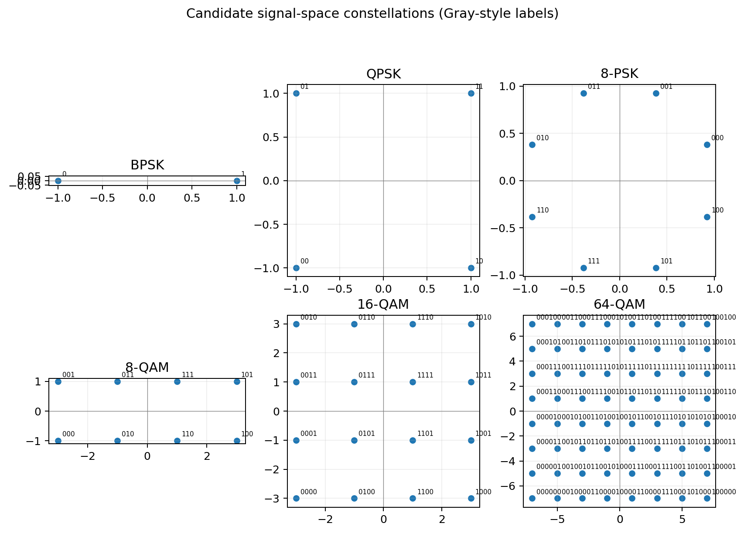
Figure 1. Candidate signal-space constellations. Coordinates are illustrative and not all plots use the same scale.

3.1 Normalised constellation metrics
Scheme | Bits/symbol | dmin² / Eb | PAPR (linear) | PAPR (dB) | Efficiency (bit/s/Hz)
BPSK | 1 | 4.000 | 1.000 | 0.00 | 0.80
QPSK | 2 | 4.000 | 1.000 | 0.00 | 1.60
8-PSK | 3 | 1.757 | 1.000 | 0.00 | 2.40
8-QAM (4×2 rectangular) | 3 | 2.000 | 1.667 | 2.22 | 2.40
16-QAM (square) | 4 | 1.600 | 1.800 | 2.55 | 3.20
64-QAM (square) | 6 | 0.571 | 2.333 | 3.68 | 4.80

For PSK, all ideal constellation points lie on a circle, so the symbol-envelope PAPR is 1 (0 dB), ignoring pulse shaping. For square M-QAM, the peak symbol energy is greater than the average energy. The values above use the conventional square grids with equally likely symbols. The 8-QAM case is explicitly defined as a rectangular 4×2 grid.

3.2 Minimum-distance reasoning
- BPSK: two points separated by 2√Eb, giving dmin² = 4Eb.
- QPSK: with Es = 2Eb, adjacent points are separated by √(2Es), giving dmin² = 4Eb.
- 8-PSK: dmin² = 4Es sin²(π/8), with Es = 3Eb, giving 12sin²(π/8)Eb ≈ 1.757Eb.
- Rectangular 8-QAM: grid spacing is 2a and average Es = 6a² = 3Eb, hence dmin² = 4a² = 2Eb.
- 16-QAM: average Es = 10a² = 4Eb, while dmin² = 4a², hence dmin² = 1.6Eb.
- 64-QAM: average Es = 42a² = 6Eb, while dmin² = 4a², hence dmin² = 4/7Eb ≈ 0.571Eb.

3.3 Required Eb/N0 for BER = 10⁻⁶
The following thresholds use coherent AWGN detection. BPSK/QPSK use the exact expression Pb=Q(√(2Eb/N0)). The 8-PSK entry uses a nearest-neighbour approximation. Square QAM uses the common Gray-coded approximation. The 8-QAM value is an engineering estimate for the selected rectangular constellation and should be refined with a dedicated simulation.
Scheme | Approx. Eb/N0 for 10⁻⁶ | Model / comment
BPSK | 10.53 dB | Exact coherent AWGN
QPSK | 10.53 dB | Same bit-error curve as BPSK
8-PSK | 13.95 dB | Nearest-neighbour approximation
8-QAM | ≈15.0 dB | Approximate; verify by Monte Carlo
16-QAM | 14.40 dB | Gray-coded square-QAM approximation
64-QAM | 18.78 dB | Gray-coded square-QAM approximation

3.4 Why 16-QAM is more power-efficient than 16-PSK
Both schemes carry four bits per symbol, but their points are arranged differently. In square 16-QAM, the normalised minimum squared distance is 1.6Eb. In 16-PSK, dmin²/Eb = 16sin²(π/16) ≈ 0.609. Thus, at the same average Eb, the nearest 16-QAM points are farther apart. Larger decision-point separation makes noise less likely to push a received symbol across a decision boundary, so 16-QAM needs less Eb/N0 for a given BER. The trade-off is that QAM has a varying envelope and higher PAPR, so it requires a more linear power amplifier.

3.5 Ranked shortlist
Rank / use | Scheme | Reason
1 – Clear sky | 16-QAM | Carries full traffic within 5 MHz with useful link margin; moderate complexity.
2 – Rain fade | QPSK | Robust BER and sufficient capacity for the always-on 2.496 Mb/s traffic.
3 – Reference | BPSK | Very robust reference but lower spectral efficiency than QPSK.
Capacity alternative | 64-QAM | Highest rate but higher Eb/N0 requirement and PAPR; less rain robustness.

The central trade-off is power efficiency versus bandwidth efficiency: low-order schemes have larger noise tolerance but lower bits per symbol; high-order QAM carries more bits per symbol but requires better signal quality and a more linear amplifier.
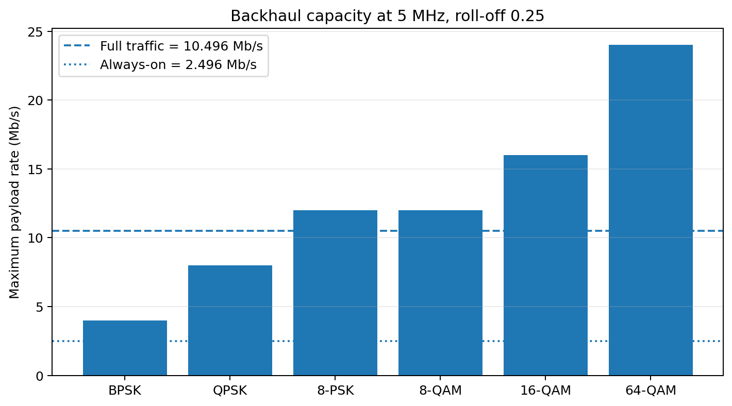
Figure 2. Maximum uncoded payload capacity for each candidate in the 5 MHz channel.

4. Stage 3 – Backhaul Feasibility and Adaptive Modulation

4.1 Maximum rates
Scheme | Bits/symbol | Maximum rate at Rs=4 Msym/s | Full traffic? | Always-on?
BPSK | 1 | 4.00 Mb/s | No | Yes
QPSK | 2 | 8.00 Mb/s | No | Yes
8-PSK | 3 | 12.00 Mb/s | Yes | Yes
8-QAM | 3 | 12.00 Mb/s | Yes | Yes
16-QAM | 4 | 16.00 Mb/s | Yes | Yes
64-QAM | 6 | 24.00 Mb/s | Yes | Yes

The 5 MHz channel can carry the full 10.496 Mb/s only with at least 3 bits/symbol under the specified pulse shaping. 8-PSK and 8-QAM have nominal maximum rates of 9.6 Mb/s and therefore fall short of full traffic. 16-QAM and 64-QAM have sufficient nominal capacity.

4.2 Available Eb/N0 and margin
At the full payload rate, available Eb/N0 is 91 − 10log₁₀(10.496×10⁶) = 20.79 dB in clear sky, and 82 − 10log₁₀(10.496×10⁶) = 11.79 dB during rain fade.
When the link is reduced to the always-on payload, the available Eb/N0 during rain fade rises to 18.03 dB. This is because the bit rate is reduced while the received C/N0 is held at the specified rain-fade value.
Scheme | Required Eb/N0 | Clear-sky margin at full rate | Rain margin at full rate | Meets ≥3 dB in clear sky?
BPSK | 10.53 dB | 10.26 dB | 1.26 dB | Yes
QPSK | 10.53 dB | 10.26 dB | 1.26 dB | Yes
8-PSK | 13.95 dB | 6.84 dB | -2.16 dB | Yes
16-QAM | 14.40 dB | 6.39 dB | -2.61 dB | Yes
64-QAM | 18.78 dB | 2.01 dB | -6.99 dB | No

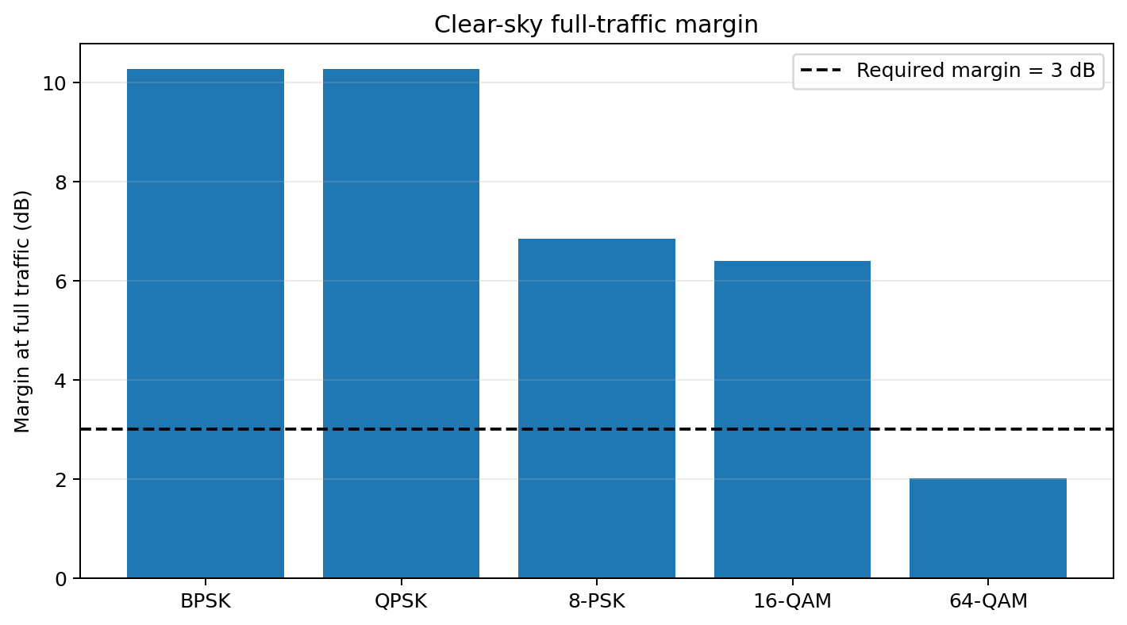
Figure 3. Clear-sky margin at the full offered payload rate. A margin of at least 3 dB is required.

4.3 Feasibility matrix
Scheme / condition | Capacity for full traffic | BER and ≥3 dB margin at full rate | Decision
BPSK – clear sky | No (3.2 Mb/s max) | BER margin ample at low rate, but capacity fails | Not feasible for full traffic
QPSK – clear sky | No (6.4 Mb/s max) | Capacity fails | Not feasible for full traffic
8-PSK – clear sky | No (9.6 Mb/s max) | Capacity fails | Not feasible for full traffic
16-QAM – clear sky | Yes (12.8 Mb/s max) | 20.79 − 14.40 = 6.39 dB | Feasible
64-QAM – clear sky | Yes (19.2 Mb/s max) | 20.79 − 18.78 = 2.01 dB | Capacity yes; margin no (marginal)
All candidates – rain at full rate | Only 16/64-QAM have enough nominal capacity | Available 11.79 dB is below 16/64-QAM BER thresholds | Not feasible for full traffic
QPSK – rain, always-on rate | Yes (6.4 Mb/s max) | 18.03 − 10.53 = 7.50 dB | Feasible for always-on traffic

4.4 Design decisions
Design Decision 1 – Clear sky: I recommend 16-QAM because its 12.8 Mb/s maximum uncoded rate exceeds the 10.496 Mb/s payload, and its calculated clear-sky operating margin is approximately 6.39 dB, exceeding the operator’s 3 dB requirement.
Design Decision 2 – Rain fade: I recommend QPSK, carrying the 30 PCM voice channels and 120-sensor IoT traffic (2.496 Mb/s). The four school/health data streams (8 Mb/s) are suspended or queued for later delivery. At 2.496 Mb/s, the available Eb/N0 is approximately 18.03 dB, giving about 7.50 dB above the QPSK 10⁻⁶ threshold.
No candidate can carry the full 10.496 Mb/s during the specified rain fade and meet the BER target. Even the 16-QAM available Eb/N0 is short by approximately 2.61 dB before the operator’s 3 dB margin is added; the total gap to the required threshold plus margin is approximately 5.61 dB. 64-QAM is still less suitable.

4.5 Adaptive-modulation control
- Monitor received C/N0, estimated Eb/N0, demodulator BER and frame error rate.
- Use 16-QAM only when the estimated margin remains above 3 dB with hysteresis to avoid rapid switching.
- When the margin approaches the threshold, change to QPSK and remap the frame to retain voice and IoT.
- Queue non-real-time school/health traffic during fade and retransmit it after link quality recovers.

5. Stage 4 – Multiplexing and Switching Design

5.1 TDM versus FDM
Criterion | TDM | FDM
Guard-band / framing | Needs frame alignment and signalling overhead; no inter-subchannel guard bands. | Needs guard bands between channels, reducing usable spectrum.
Spectral efficiency | High when one carrier uses the full allocated bandwidth. | Lower if multiple guard bands are reserved.
Rain-fade adaptation | Slots can be reassigned or removed while retaining one carrier. | Each sub-band may need separate modulation and filtering.
Synchronisation | Requires timing recovery and frame synchronisation. | Requires accurate frequency generation and channel filtering.
Complexity | Digital framing, buffering and scheduling. | Multiple RF filters/channels and frequency planning.

Design Decision 3: I recommend TDM because voice, IoT and variable-rate data can be carried in one digital frame. During rain fade, the scheduler can preserve voice and IoT slots and remove or defer data slots without redesigning separate RF subchannels.

5.2 Proposed frame structure
Use a 125 μs frame interval as a convenient PCM-compatible framing period. Each 64 kb/s voice channel contributes 8 bits per frame. Thus, 30 voice channels require 30 × 8 = 240 bits per frame, equivalent to 1.920 Mb/s. The 120 sensors are aggregated at the node; their 0.576 Mb/s payload contributes 72 bits per 125 μs frame on average. Four independent data streams contribute 250 bytes per stream per 125 μs frame at 2 Mb/s each.
Frame component | Bits per 125 μs frame | Equivalent rate
30 PCM voice channels | 240 bits | 1.920 Mb/s
Aggregated IoT payload | 72 bits average | 0.576 Mb/s
Four data streams | 1,000 bits each; 4,000 total | 8.000 Mb/s
Payload total | 4,312 bits | 10.496 Mb/s
Suggested framing/signalling reserve | 0.5% planning allowance | ≈52.7 kb/s
Indicative line rate | 4,312 ÷ 125 μs × 1.005 | ≈10.549 Mb/s

The 0.5% framing/signalling allowance is a design assumption, not specified in the assignment. The resulting 10.549 Mb/s line rate fits within the 16-QAM maximum rate of 12.8 Mb/s. The unused capacity is approximately 2.25 Mb/s before any additional implementation-specific coding overhead.
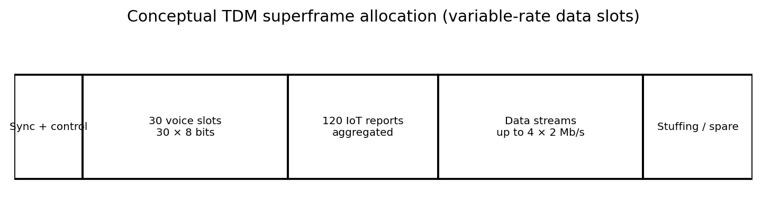
Figure 4. Conceptual TDM superframe allocation. Exact slot boundaries and signalling fields are implementation parameters.

5.3 Independent data-stream clocks and justification
Each data stream has an independent clock of 2 Mb/s ±50 ppm. The maximum fractional rate error is 50×10⁻⁶. For one 2 Mb/s stream, the maximum rate difference is 2,000,000 × 50×10⁻⁶ = 100 bit/s. Over a 125 μs frame, this is 0.0125 bit per stream on average. A practical elastic buffer with controlled bit stuffing or justification can absorb this small difference.
A conservative positive justification capacity of at least 100 bit/s per stream is required to accommodate a +50 ppm source relative to the nominal rate. For four streams, reserve at least 400 bit/s total in the positive direction, with corresponding negative justification handling and buffer monitoring. A real implementation should add margin for justification granularity and pointer/control signalling.

5.4 Rain-fade frame remapping
Traffic element | Clear-sky frame | Rain-fade frame
30 voice channels | Retain all 240 bits/frame | Retain all 240 bits/frame
IoT | Retain aggregated sensor reports | Retain 72 bits/frame average; queue if temporarily congested
Four 2 Mb/s data streams | Allocate up to 4,000 bits/frame | Remove/defer all four streams during the severe fade
Control / alignment | Retain | Retain; signal the new frame profile

5.5 TSI switch and space-division comparison
A time-slot interchange (TSI) switch can map any of the 30 incoming voice channels to any outgoing voice slot. For 30 channels with 8-bit PCM words, the data memory needs 30 × 8 = 240 bits per frame. A control memory needs 30 address entries, each wide enough to identify one of 30 input channels: ceil(log₂30)=5 bits, so 150 control bits. Total logical storage is therefore approximately 390 bits, excluding implementation overhead.
At 30 voice slots per 125 μs frame, the slot interval is 125 μs / 30 = 4.167 μs. The memory access time must be shorter than one slot interval for a single-access-per-slot architecture. If separate read and write operations are required within the slot, each operation should complete in less than approximately 2.08 μs. Faster access provides implementation margin.
An equivalent fully connected 30-input by 30-output space-division crossbar requires 30 × 30 = 900 crosspoints. TSI is attractive for this small digital voice group because it uses compact memory and programmable mapping; a space switch can offer direct paths but requires many crosspoints and more switching hardware.

5.6 Complete node arrangement
- Ingress interfaces receive PCM voice, four independent data streams and aggregated IoT reports.
- Elastic buffers absorb clock differences; a justification controller inserts/removes controlled stuffing bits.
- A digital multiplexer forms the 125 μs TDM superframe and inserts alignment and signalling.
- A TSI stage maps incoming voice channels to the required outgoing voice slots.
- The adaptive modem selects 16-QAM in clear sky and QPSK during the specified severe rain fade.
- At the PoP, the receiver demodulates, aligns frames, demultiplexes traffic and forwards it to the fibre network.

6. Stage 5 – Simulation-Based BER Investigation

6.1 AWGN experiment and theoretical reference
The Monte Carlo chain is: random bit source → symbol mapper → AWGN channel → detector/demapper → error counter. The three schemes selected for the comparison are BPSK (robust reference), QPSK (rain-fade choice) and 16-QAM (clear-sky choice). The theoretical curves use the expressions described in Stage 2.
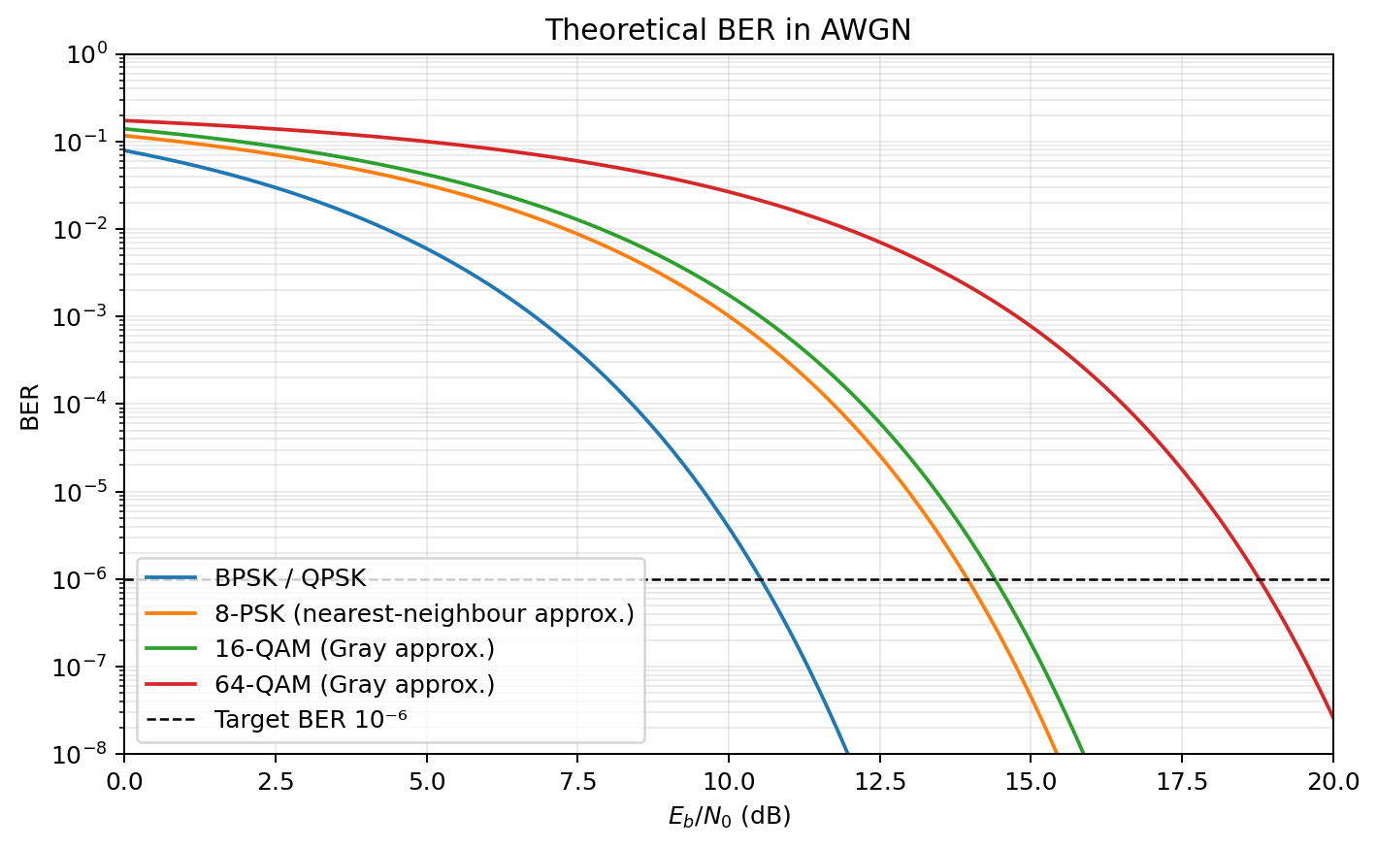
Figure 5. Theoretical BER against Eb/N0 in AWGN. The 8-PSK and QAM expressions are standard approximations.
For BPSK/QPSK, Pb = Q(√(2γb)). For square Gray-coded M-QAM, the approximate bit-error expression used is Pb ≈ [4/log₂M × (1−1/√M)] Q(√[3log₂M/(M−1) × γb]). The 8-PSK approximation is a nearest-neighbour expression. The exact simulation should use the same bit mapping and normalisation as the theoretical reference.

6.2 Simulation trial count and rare errors
A measured BER is errors divided by transmitted bits. At BER 10⁻⁶, a simulation of only 100,000 bits has an expected error count of 0.1 and cannot reliably demonstrate the target. Approximately 10⁶ bits gives only about one expected error; approximately 10⁷ bits gives about ten expected errors. For a more stable estimate, many more bits are needed. Therefore, the report should use direct Monte Carlo results where enough errors occur and use validated theoretical curves or confidence bounds to support the 10⁻⁶ region.
The simulation code should report the actual number of bits and errors at each Eb/N0 point. If zero errors occur, report an upper confidence bound rather than writing BER = 0. The common rule-of-three approximation gives a 95% upper bound of about 3/N after zero errors in N independent bits.

6.3 Practical impairment: carrier phase offset
Selected impairment: constant carrier phase offset θ = 0°, 10° and 20°. Hypothesis: 16-QAM will be more sensitive than BPSK/QPSK because its decision regions are more closely spaced and its square constellation is rotated relative to the receiver’s assumed axes. A constant phase offset rotates every received symbol; a practical carrier-recovery loop should estimate and correct it.
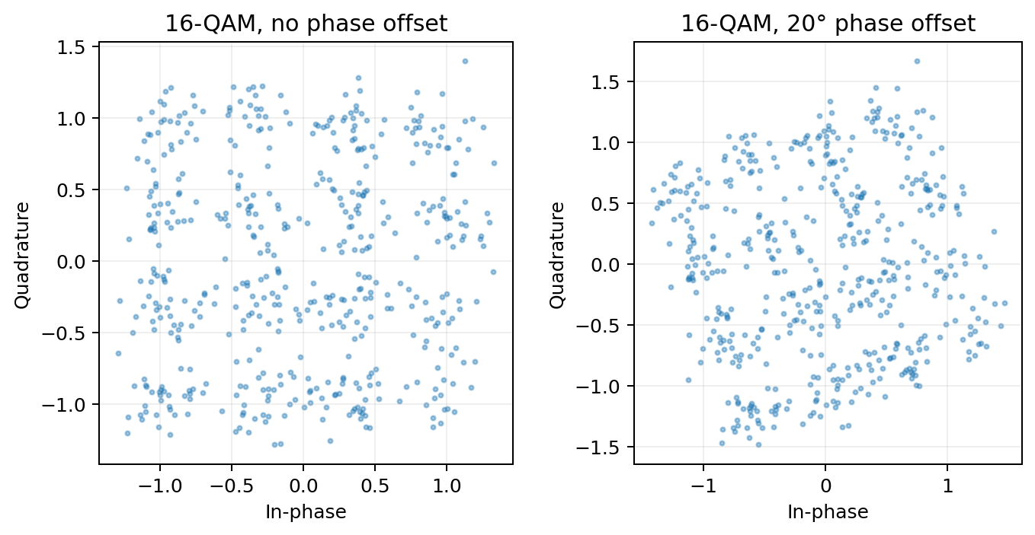
Figure 6. Illustrative 16-QAM received constellation with and without a 20° phase offset.
Eb/N0 is defined from the average transmitted bit energy divided by the AWGN noise spectral density before the phase rotation. The phase offset does not change transmitted energy; it changes the alignment between the received constellation and the detector. In a receiver with no phase correction, the BER penalty is caused by decision errors from the rotated decision geometry.
Phase offset | Expected effect | Design implication
0° | Reference constellation; no rotation penalty. | Baseline receiver performance.
10° | Small but visible rotation; higher-order QAM may show a measurable BER increase. | Carrier recovery should track modest phase error.
20° | Larger rotation; 16-QAM is expected to show more decision-boundary errors. | Require phase estimation/correction or reduce modulation order.

The plotted scatter is illustrative and demonstrates the geometric effect; it is not a measured BER result. A numerical penalty at BER 10⁻⁴ must be obtained by running the complete Monte Carlo detector with each phase offset. Do not claim a measured dB penalty from the scatter plot alone.

6.4 Interpreting the experiment
The hypothesis is supported qualitatively by the geometry: higher-order QAM has smaller normalised nearest-neighbour separation and is more vulnerable to constellation rotation. The final design should include carrier recovery and a modulation downgrade trigger. If the measured phase-offset penalty exceeds the available clear-sky margin, 16-QAM should not be retained until phase synchronisation is restored.

7. Stage 6 – Sensor Link: Constant-Envelope Modulation

7.1 Candidate comparison
Scheme | Envelope / amplifier | Detection | Approx. Eb/N0 for BER 10⁻³ | Assessment
ASK / OOK | Variable envelope; inefficient with saturated PA. | Usually envelope / coherent options; simple but amplitude-sensitive. | ≈6.8 dB coherent OOK reference; implementation dependent. | Low complexity but poor fit to non-linear saturated PA.
Non-coherent BFSK | Constant envelope for ideal FSK. | Non-coherent; low receiver complexity. | ≈10.94 dB for orthogonal non-coherent BFSK. | Good saturated-PA compatibility; modest bandwidth.
MSK | Constant envelope and continuous phase. | Typically coherent; non-coherent variants possible. | ≈6.8 dB coherent MSK reference. | Excellent spectral sidelobe behaviour; receiver can be more complex.
BPSK | Constant envelope at symbol points; pulse shaping may vary envelope. | Coherent carrier recovery required. | ≈6.79 dB coherent BPSK. | Power-efficient, but coherent receiver is less aligned with preference.

The thresholds are ideal AWGN reference values. Actual implementation losses, frequency error, timing error, filtering and packet retransmissions will change system-level performance. Non-coherent orthogonal BFSK uses Pb = 0.5 exp(−Eb/(2N0)); setting Pb=10⁻³ gives approximately 10.94 dB.

7.2 Power spectral density and phase continuity
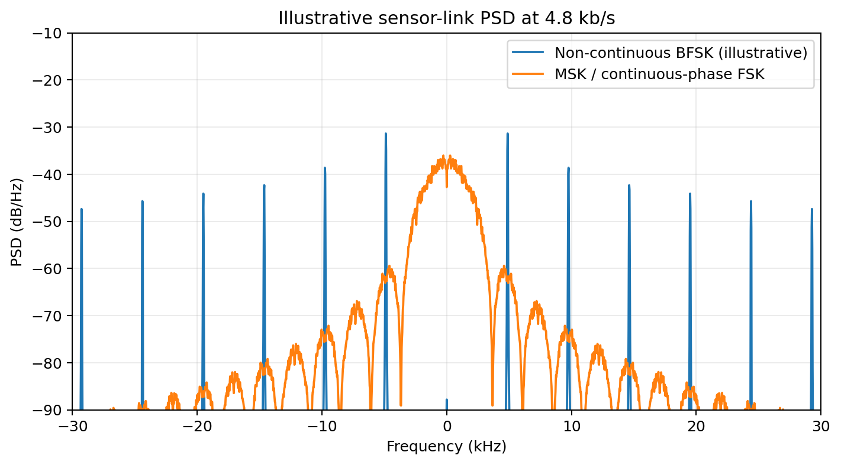
Figure 7. Illustrative PSD comparison at 4.8 kb/s. Continuous phase suppresses abrupt phase transitions and generally improves spectral sidelobe decay.
In ordinary non-continuous BFSK, the phase may jump at bit boundaries when the oscillator phase is restarted. Abrupt phase discontinuities create additional high-frequency spectral components and stronger sidelobes. MSK is continuous-phase FSK with modulation index h=0.5; the phase remains continuous at symbol transitions, producing a more compact spectrum and faster sidelobe decay. This helps reduce interference into adjacent channels.
The figure is an illustrative numerical waveform estimate, not a standards mask or a calibrated RF measurement. For a final lab submission, generate both waveforms with identical bit sequences, sampling frequency, observation duration and PSD normalisation, and label the actual implementation parameters.

7.3 Sensor multiplexing choice
The aggregate sensor payload is 120 × 4.8 kb/s = 576 kb/s, below the 1 MHz shared-band allocation. TDM is recommended: sensors transmit in assigned time slots under node scheduling, avoiding the need for 120 accurately separated carrier frequencies. Each sensor still needs timing synchronisation and a guard interval between bursts to tolerate clock and propagation uncertainty.
FDM would require 120 frequency channels, nominally 1 MHz/120 ≈ 8.33 kHz per sensor before guard bands. Low-cost oscillators can drift, and guard bands reduce the usable bandwidth. TDM shifts the main accuracy requirement from frequency stability to timing synchronisation, which can be managed by periodic beacons and scheduled uplink windows.
Design Decision 4: I recommend non-coherent BFSK with TDM for the sensor link because BFSK has a constant envelope, works with saturated power amplifiers, supports non-coherent low-cost detection, and TDM avoids allocating 120 tightly controlled frequency channels. The cost is timing synchronisation and a somewhat higher ideal Eb/N0 requirement than coherent BPSK/MSK.

8. Stage 7 – QAM in 4G and 5G Systems
4G LTE and 5G NR use link adaptation: the base station estimates channel quality from reference signals and feedback, then selects a modulation and coding scheme (MCS) that balances throughput and error probability. The selected MCS depends on radio conditions, implementation capability and scheduling policy.
System | Downlink modulation (typical supported orders) | Uplink modulation (typical supported orders) | Link-adaptation note
LTE | QPSK, 16-QAM, 64-QAM; 256-QAM support added in later LTE releases/capabilities. | QPSK, 16-QAM, 64-QAM; 256-QAM support depends on release and UE capability. | CQI feedback supports MCS selection; uplink MCS also considers power and UE capability.
5G NR | π/2-BPSK, QPSK, 16-QAM, 64-QAM, 256-QAM depending on channel/configuration. | π/2-BPSK, QPSK, 16-QAM, 64-QAM, 256-QAM depending on configuration and capability. | CSI/CQI and MCS tables are used to select modulation and coding rate.

π/2-BPSK is included for the NR uplink to support low-PAPR transmission, which is useful for a power-limited user device and its power amplifier. This connects to Stage 6: constant- or near-constant-envelope signals can be more tolerant of non-linear amplification and may improve transmitter power efficiency.
One difference from the proposed rural backhaul is the control granularity and environment. LTE/NR adapt MCS dynamically across scheduled radio resources using standardised channel feedback and coding schemes. The proposed microwave backhaul uses a small set of link-wide modes and a service-priority policy: it switches the entire backhaul between 16-QAM and QPSK and deliberately drops/defer non-critical traffic during severe rain fade.

9. Final Engineering Decision
RECOMMENDATION: YES, WITH ADAPTIVE OPERATION AND A DEFINED RAIN-FADE SERVICE POLICY
The link is recommended for commissioning only if the operator accepts that the four school/health data streams will be temporarily suspended or queued during the specified worst-case rain fade. The system cannot meet the full 10.496 Mb/s payload and the required BER/margin in that condition using the stated 5 MHz allocation and received C/N0. It can preserve the 2.496 Mb/s always-on voice and IoT traffic using QPSK.
Requirement | Specified | Achieved – clear sky | Achieved – rain fade | Satisfied?
Payload bit rate | Full traffic | 10.496 Mb/s with 16-QAM; line rate ≈10.549 Mb/s | 2.496 Mb/s retained; 8 Mb/s data deferred | Yes in clear; no for full traffic in rain
Voice and IoT | At all times | 1.920 + 0.576 Mb/s | 1.920 + 0.576 Mb/s | Yes, subject to functioning fallback
Data streams | 4 × 2 Mb/s | All four carried | 0 carried live; queued | No during severe fade
Backhaul BER | ≤10⁻⁶ | Design target supported by 16-QAM margin | QPSK target supported at reduced rate | Yes for selected operating profiles
Operating margin | ≥3 dB | ≈6.39 dB at full rate / 16-QAM | ≈7.50 dB for always-on / QPSK | Yes for selected profiles
Sensor BER | ≤10⁻³ | Non-coherent BFSK design target | Same sensor-link target; retransmission available | Expected; verify by sensor test
RF channel bandwidth | 5 MHz | 5 MHz | 5 MHz | Yes
Spare capacity | Future growth | 16-QAM max 12.8 Mb/s; ≈2.25 Mb/s after assumed overhead | QPSK max 6.4 Mb/s; ample headroom over 2.496 Mb/s | Limited in clear sky

9.1 Reasons supporting the decision
- The full clear-sky payload fits with 16-QAM and an estimated margin of 6.39 dB, above the 3 dB operator requirement.
- During rain fade, 16-QAM cannot meet the BER target at full payload. The system therefore changes to QPSK and preserves the always-on services.
- TDM provides flexible traffic remapping and allows the four non-real-time streams to be queued.
- The TSI voice switch supports flexible mapping of 30 incoming voice channels with modest memory requirements.
- Non-coherent BFSK is compatible with the sensor transmitter’s saturated amplifier and low-cost receiver preference.
- The phase-offset investigation identifies carrier synchronisation as a necessary modem function, particularly for 16-QAM.

9.2 Redesign if all four data streams must remain live in rain
If the operator requires all 10.496 Mb/s during the worst-case rain fade, the present specification is insufficient. For 16-QAM, the available Eb/N0 at full payload is 11.79 dB. The approximate required Eb/N0 is 14.40 dB, so the BER-only shortfall is 2.61 dB. Including the required 3 dB operating margin, the received C/N0 must increase by approximately 5.61 dB at the same bit rate. This can be pursued through additional antenna gain, improved link budget, higher transmit power within regulatory limits, additional channel bandwidth, or forward error correction. Each change must be checked for regulatory, hardware and cost constraints.
A bandwidth redesign is another option: increasing the channel bandwidth can reduce the required spectral efficiency and allow a lower-order modulation. However, a larger bandwidth alone does not increase the received C/N0; the link budget and noise bandwidth must be recalculated together. Stronger FEC can reduce the required demodulator Eb/N0 but adds coding overhead and latency.

9.3 Limitations and validation required before deployment
- The 8-QAM BER threshold is approximate and should be measured with the selected rectangular constellation.
- The frame overhead is assumed to be 0.5%; final alignment, signalling, coding and guard requirements must be specified.
- The phase-offset scatter plot is illustrative; the exact BER penalty at 10⁻⁴ must be measured using the complete receiver simulation.
- The sensor PSD figure is illustrative; final tests must use the exact pulse shaping, filtering and RF implementation.
- The rain-fade C/N0 is treated as a fixed worst-case value. Real deployments should include fade dynamics, hysteresis and measured availability.
10. References
[1] J. G. Proakis and M. Salehi, Digital Communications, 5th ed., McGraw-Hill, 2008.
[2] B. Sklar, Digital Communications: Fundamentals and Applications, 2nd ed., Prentice Hall, 2001.
[3] S. Haykin, Communication Systems, 5th ed., Wiley, 2009.
[4] 3GPP TS 36.211, Evolved Universal Terrestrial Radio Access (E-UTRA); Physical Channels and Modulation.
[5] 3GPP TS 36.213, E-UTRA; Physical Layer Procedures.
[6] 3GPP TS 38.211, NR; Physical Channels and Modulation.
[7] 3GPP TS 38.214, NR; Physical Layer Procedures for Data.
[8] J. B. Anderson, T. Aulin and C.-E. Sundberg, Digital Phase Modulation, Plenum Press, 1986.
[9] J. G. Proakis, “Digital Communications,” sections on coherent/non-coherent detection and AWGN error probability.

Appendix A – Simulation implementation outline
The following Python outline gives the core steps for a reproducible AWGN BER experiment. It is an implementation guide: extend the mapper/demapper to include Gray-coded QPSK and 16-QAM, report the actual bit and error counts, and run sufficient trials for the BER region being claimed.
import numpy as np
from scipy.special import erfc
def qfunc(x):
return 0.5 * erfc(x / np.sqrt(2))
def bpsk_awgn_ber(EbN0_dB, nbits=2_000_000, seed=7):
rng = np.random.default_rng(seed)
bits = rng.integers(0, 2, nbits)
symbols = 1 - 2*bits # BPSK: 0 -> +1, 1 -> -1
gamma = 10**(EbN0_dB/10)
sigma = np.sqrt(1/(2*gamma)) # unit-energy bit convention
noise = rng.normal(0, sigma, nbits)
received = symbols + noise
detected = (received < 0).astype(int)
errors = np.count_nonzero(bits != detected)
ber = errors / nbits
return ber, errors, nbits
for ebn0 in range(0, 21, 2):
ber, errors, nbits = bpsk_awgn_ber(ebn0)
print(ebn0, ber, errors, nbits)
For QPSK and 16-QAM, use a consistent Gray mapping and normalise the average symbol energy to the required Es. Add independent Gaussian noise to the I and Q components with variance derived from N0. For the phase-offset experiment, rotate the received complex samples by exp(jθ) before the detector and keep the Eb/N0 definition tied to the transmitted average bit energy.

Appendix B – Key results at a glance
Parameter | Result
Full backhaul payload | 10.496 Mb/s
Always-on backhaul payload | 2.496 Mb/s
Maximum symbol rate | 4 Msymbol/s
Full / always-on required spectral efficiency | 2.099 / 0.499 bit/s/Hz
Clear-sky modulation | 16-QAM
Rain-fade modulation | QPSK
Rain-fade traffic policy | Retain voice + IoT; defer four 2 Mb/s streams
Multiplexing | TDM
Sensor modulation / multiplexing | Non-coherent BFSK / TDM
Voice TSI storage | ≈240-bit data memory + 150-bit control memory
Space-switch crosspoints | 900

